
PRODUCT SPECIFICATION

Brand | C.K
Product Range | Draw tapes
Catalogue number | 5391
Date | 20/02/2007

Range Description  Electricians draw tapes – designed for drawing electrical wire through conduit, trunking etc. |  | 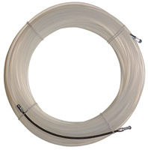  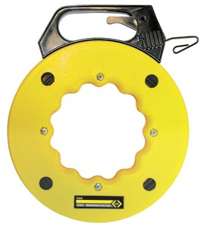
Features

495005,6 & 7
- Extra strong Perlon tape for performance and reliability
- Smooth surface for a low coefficient of friction
- 190mm long spring guide avoids jamming/snagging
- Non conductive for safety
- Non corroding for a long service life

Features
495008
- Manufactured from high strength flexible spring steel
- Hooked end to avoid snagging in use
- Housed in a sturdy rotating plastic storage case for convenience
- Brake trigger mechanism in the handle
Item Number | Item Description | EAN No | Commodity code | Carton Qty
495005 | Draw in tape 10m | 5051074950055 | 82055990 | 3
495006 | Draw in tape 20m | 5051074950062 | 82055990 | 3
495007 | Draw in tape 30m | 5051074950079 | 82055990 | 2
495008 | Electricians draw tape – 50ft/15.2m | 5051074950086 | 82055990 | 1

Technical product information

Standards compliance | None applicable
User health and safety information | None applicable
RoHS/WEEE compliance | This product does not fall within the scope of RoHS or WEEE regulations
Material safety data | None applicable
Warranty | C.K draw tapes are guaranteed for life against imperfect materials or workmanship
Country of origin | 495005,6 & 7 – Germany  495008 - Taiwan

Dimensional details

 | Product only |  |  |  | Product on primary packaging
Item | Width mm | Depth mm | Height mm | Net weight g | Width mm | Depth mm | Height mm | Gross weight g
495005 | 200 | 20 | 200 | 147 | 200 | 20 | 310 | 156
495006 | 210 | 40 | 210 | 277 | 210 | 40 | 310 | 286
495007 | 210 | 45 | 210 | 401 | 210 | 45 | 310 | 410
495008 | 215 | 28 | 270 | 950 | 215 | 28 | 270 | 959

 | Shelf box (secondary packaging) |  |  |  | Euro Pallet data Wi x Hi
Item | Width mm | Depth mm | Height mm | Gross weight g | No of cartons on base | Number of rows high
495005 | 215 | 360 | 55 | 592
495006 | 205 | 340 | 115 | 1059
495007 | 225 | 295 | 60 | 937
495008

Packaging waste details

 | Primary Packaging |  |  |  | Secondary packaging
Item | Plastic g | Use | Card g | Use | Plastic g | Use | Card g | Use
495005 |  |  | 9 | Label |  |  | 124 | Box
495006 |  |  | 9 | Label |  |  | 201 | Box
495007 |  |  | 9 | Label |  |  | 117 | Box
495008 | 8 | Shrink wrap | 1 | Label

