Tablet Enclosure

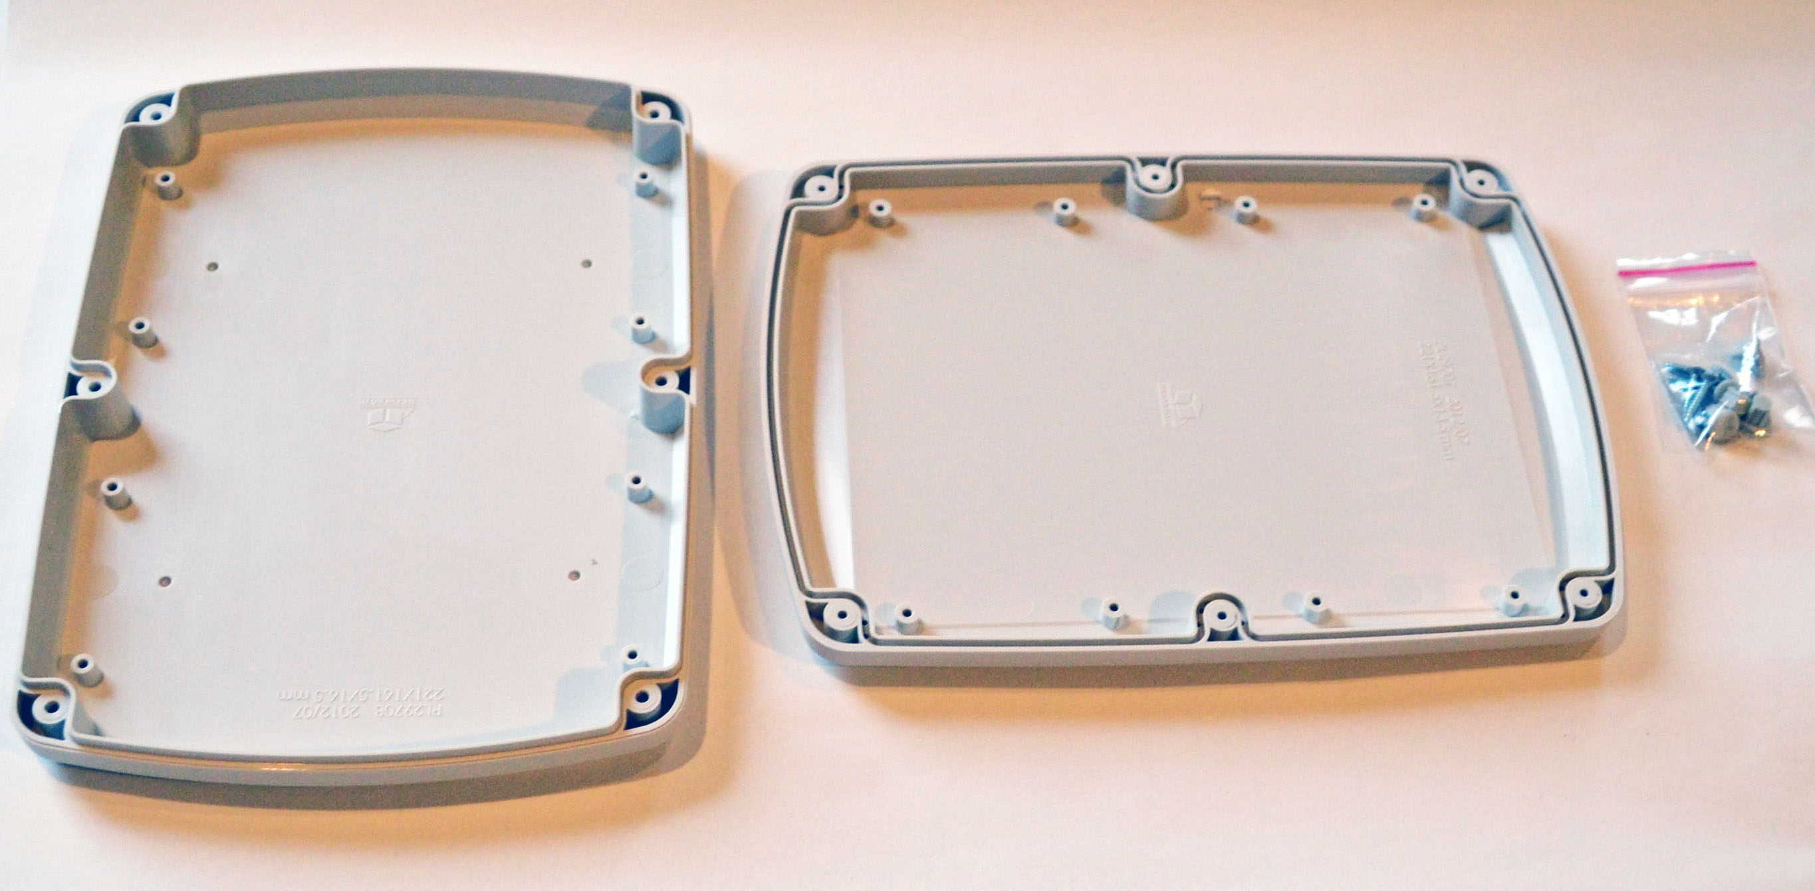 | 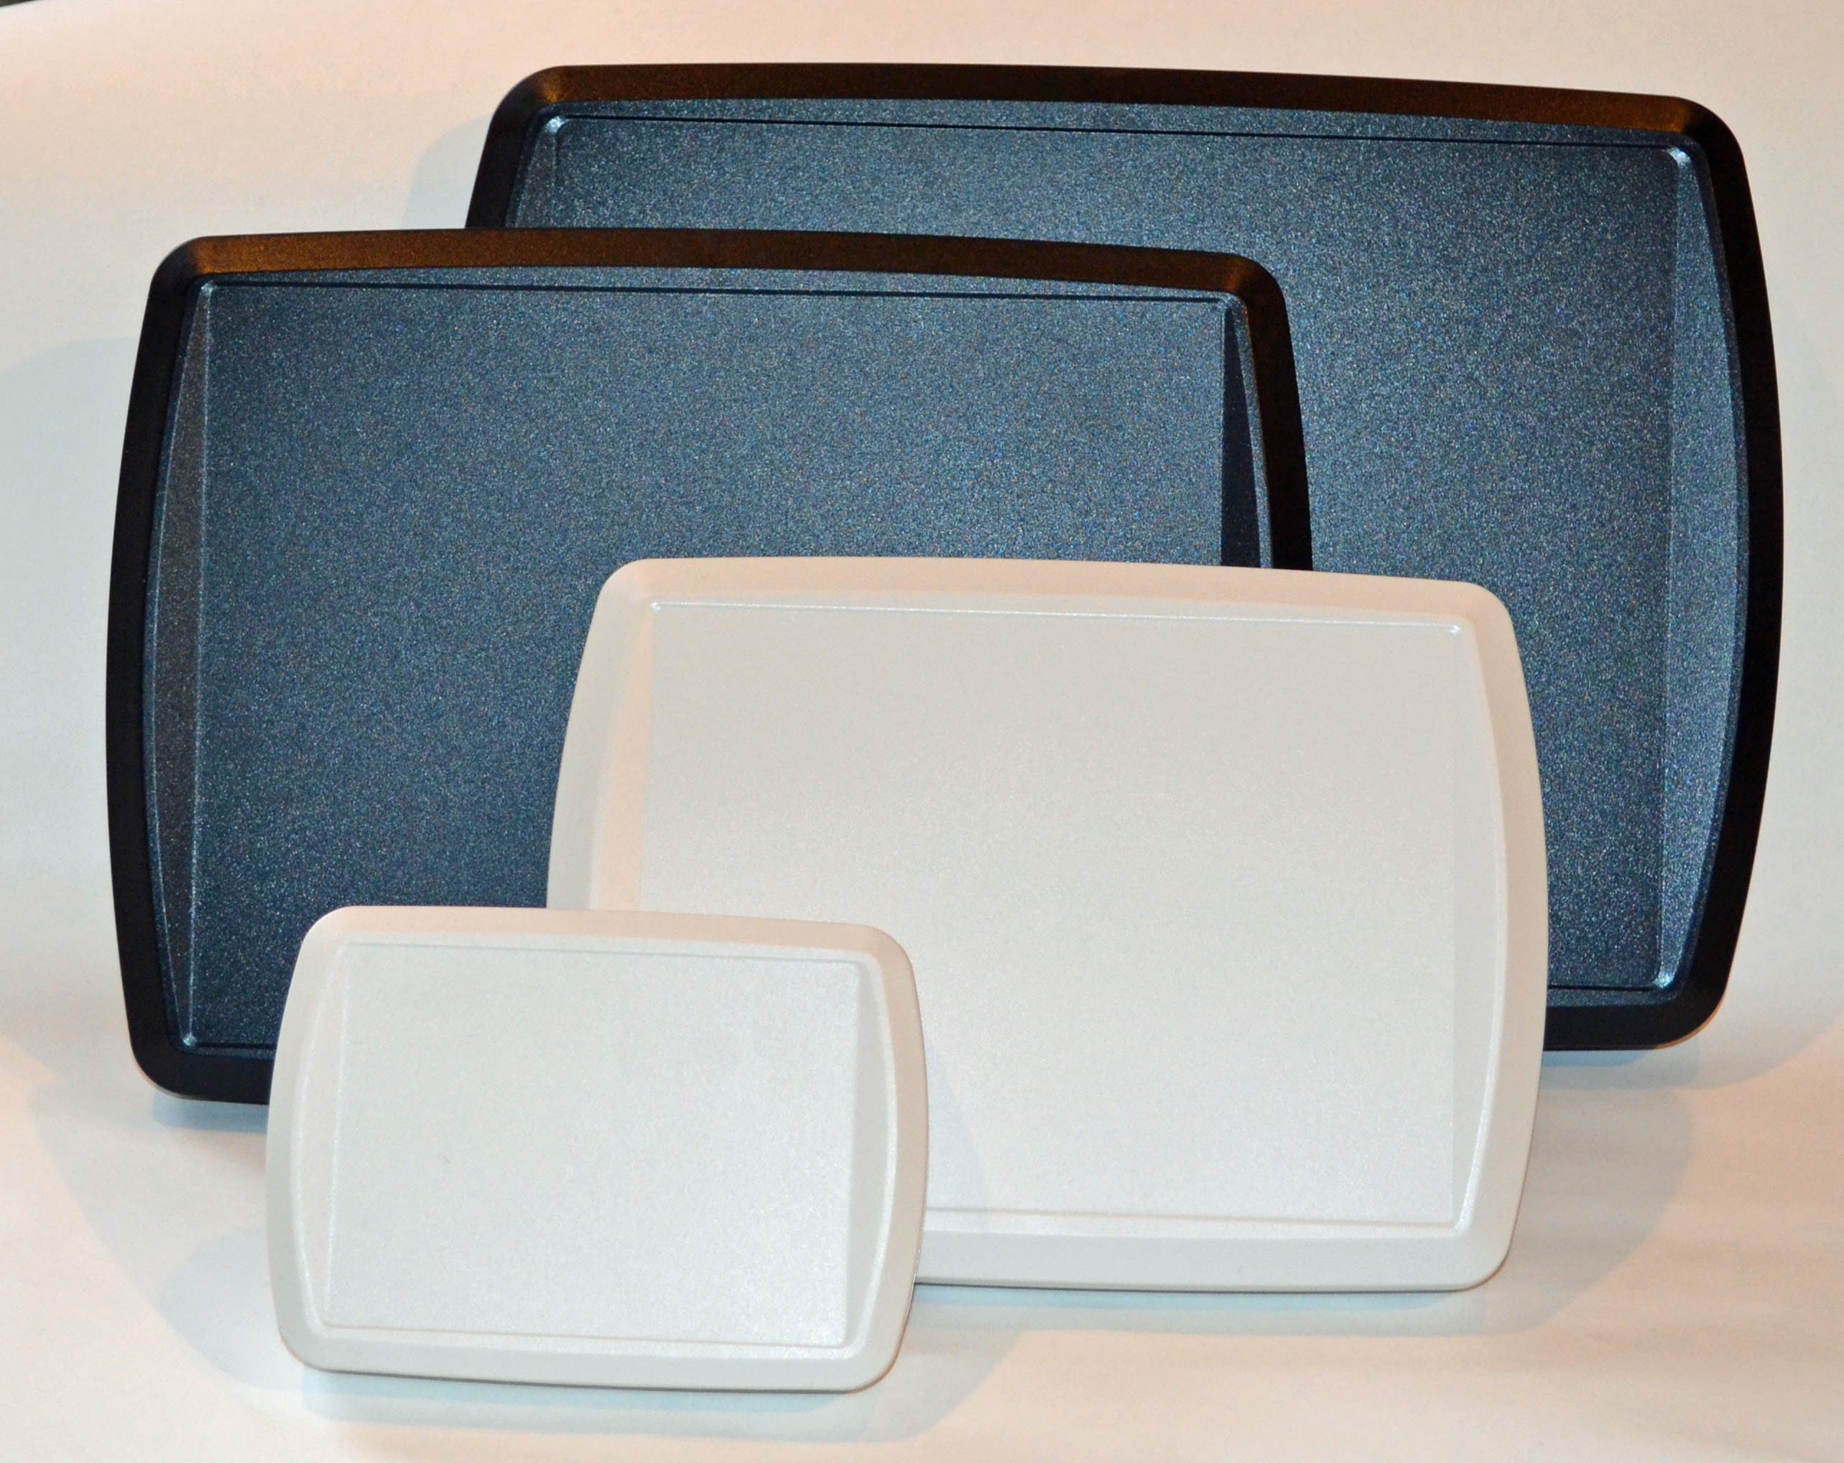
Ordering Information
BUD Catalog # | L(mm) | W(mm) | H(mm) | L(in) | W(in) | H(in)
TB-32610-B | 140 | 100 | 30 | 5.512 | 3.937 | 1.181
TB-32611-B | 190 | 150 | 30 | 7.480 | 5.906 | 1.181
TB-32612-B | 221 | 161 | 30 | 8.701 | 6.339 | 1.181
TB-32613-B | 279 | 206 | 30 | 10.984 | 8.110 | 1.181
TB-32614-B | 322 | 232 | 30 | 12.677 | 9.134 | 1.181
TB-32610-W | 140 | 100 | 30 | 5.512 | 3.937 | 1.181
TB-32611-W | 190 | 150 | 30 | 7.480 | 5.906 | 1.181
TB-32612-W | 221 | 161 | 30 | 8.701 | 6.339 | 1.181
TB-32613-W | 279 | 206 | 30 | 10.984 | 8.110 | 1.181
TB-32614-W | 322 | 232 | 30 | 12.677 | 9.134 | 1.181
GASKET INFORMATION
BUD Catalog # | Desc. | Size
TB-32610-GSK | 1 PCS OF SILICONE SPONGE GASKET FOR PL2943 USE | Φ2.3mm x 510mm
TB-32611-GSK | 1 PCS OF SILICONE SPONGE GASKET FOR PL2957 USE | Φ2.3mm x 710mm
TB-32612-GSK | 1 PCS OF SILICONE SPONGE GASKET FOR PL2970 USE | Φ2.3mm x 795mm
TB-32613-GSK | 1 PCS OF SILICONE SPONGE GASKET FOR PL2984 USE | Φ2.3mm x 1000mm
TB-32614-GSK | 1 PCS OF SILICONE SPONGE GASKET FOR PL29104 USE | Φ2.3mm x 1140mm

- Note: Units with suffix “-B” are black and are made of UL94-HB ABS plastic. Units that are suffix “-W” are white and are mode of UL94-VO ABS plastic
- Contact the factory for modifications

Benefits and Features
- Molded in high impact abs which is flame retardant to both UL94-V0 and UL94-HB.
- Available in white (RAL9002, UL94-V0 of ABS) or Black (RAL9005, UL94-HB of ABS).
- Ideally design for portable, desktop or wall mounted electronic application.
- Space of the recessed area is designed for 4.3", 5.7", 7.0", 8.4" & 10.4" LCD module or touch screen use.
- Lid & base incorporate a tongue and groove sealing design, optional EPDM gasket can be ordered and installed to meet IP65 rating of waterproof and dust.
- Recommended working temperature -20C to 80C
- Add-on rubber feet are included.

- Machine designers

